**Ex:No: 15**

Date:

**Aim:**

#### HIGH LEVEL PROGRAMMING EXTENSIONS (FUNCTIONS)

To implement Functions using program in MySQL.

##### FUNCTIONS:

A function is a subprogram that computes a value. Creating a function

The CREATE FUNCTION statement is also used in MySQL to support UDFs (user-defined functions). A UDF can be regarded as an external stored function.

##### MySQL stored function syntax

CREATE FUNCTION function_name(param1,param2,…)

RETURNS datatype [NOT] DETERMINISTIC

statements

##### Program 1:

Create a function that returns the level of a customer based on credit limit.(Use the IF statement to determine the credit limit).

The table ‘customers’ should have the following attributes: customers(cno , cname, creditlimit)

If credit limit > 50000 then customer_level = PLATINUM

If credit limit >= 10000 AND credit limit <= 50000 then customer_level = GOLD If credit limit credit limit < 10000 then customer_level = SILVER

RECURSION in Mysql Procedures

Mysql version should be >= 5.

Have to set system parameters. This means putting the recursion count limit. SET @@GLOBAL.max_sp_recursion_depth = 255;

SET @@session.max_sp_recursion_depth = 255;

##### Program 2

Write a recursive MySQL procedure compute the factorial of a number .

##### OUTPUT;

###### 1

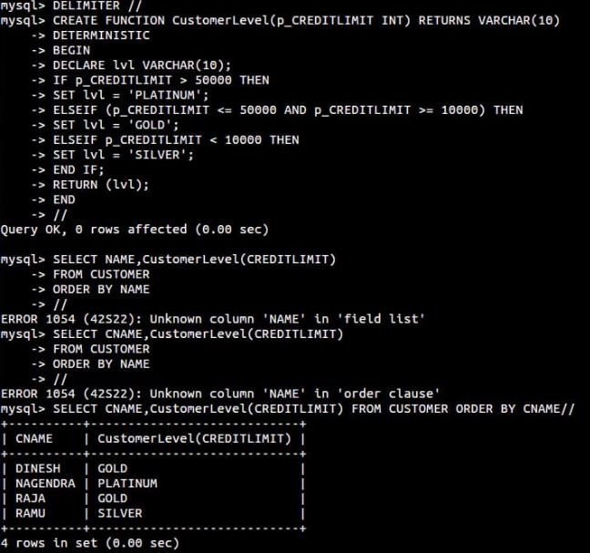

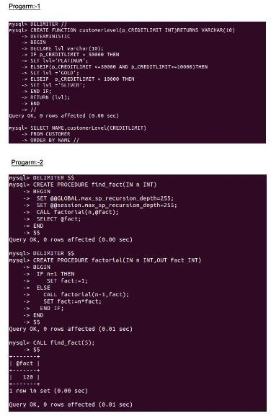**RESULT:** Thus the Functions using program in MySQL executed successfully .